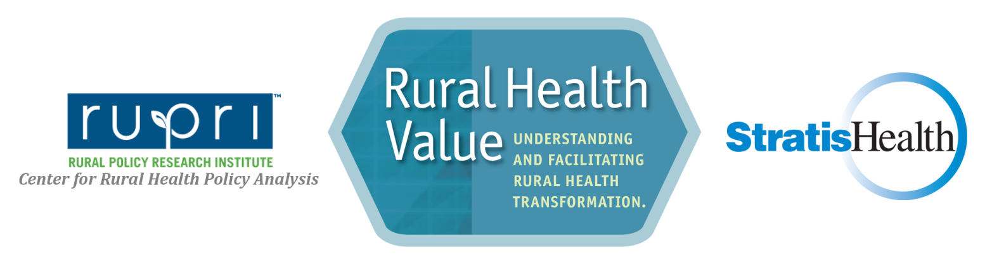

Population Health: A Self-Assessment Tool for Rural Health Providers and Organizations

Population health encompasses a cultural shift from a focus on providing care for a panel of patients when individuals are sick, to a more comprehensive view, which includes enhancing and improving the health of all individuals in a community across a spectrum of ages and conditions.

The primary goal of this self-assessment is to spark discussion, encourage debate, and help identify potential opportunities. This self-assessment tool is designed to provide a preliminary review of critical success factors for rural organizations looking to develop, expand, or enhance a population health focused approach. For more information on these critical success factors and on population health for rural providers, see Improving Population Health: A Guide for Critical Access Hospitals from the National Rural Health Resource Center
- Completion is recommended in one of two ways:
  - As a group exercise among an organizational or community-based leadership team
  - As an individual activity for leaders with responses aggregated prior to a follow-up group discussion
- If completing the assessment as a community team that encompasses multiple organizations, assess the ‘organization and staff’ questions from the perspective of each of the participating organizations to help identify opportunities within individual organizations that will help support the community effort.
- Space for notes is included for each critical success factor in the self-assessment as an opportunity to summarize key discussion points or track potential next steps.
- Use this assessment at as an initial and ongoing tool to plan and prioritize actions. Reassess progress every 12-24 months.
Instructions

Leadership and Planning | None/  Not at all | Minimal | Moderate | Advanced
- How widespread is the level of awareness regarding the critical role of population health in value-based reimbursement models?  (Please include a separate score for each of the three categories below.)  - Among key health care staff and physician leaders (e.g., hospital CEO, clinic administrator, physician leaders)?  - Among health facility boards of directors?  - Among community-based organizations, such as human and social service agencies?  Notes: Click/Tap | Click/Tap | Click/Tap | Click/Tap | Click/Tap
- Is there a shared understanding among key staff for the business case and/or rationale for a focus on population health strategies?  Notes: Click/Tap | Click/Tap | Click/Tap | Click/Tap | Click/Tap
- How well has your organization articulated a vision of how it contributes to improving the health of your community?  Notes: Click/Tap | Click/Tap | Click/Tap | Click/Tap | Click/Tap
- To what extent has your organization incorporated population health approaches as part of ongoing regular strategic planning processes?  Notes: Click/Tap | Click/Tap | Click/Tap | Click/Tap | Click/Tap

Partners and Community | None/  Not at all | Minimally | Moderately | Advanced
- How effectively has the hospital used the community health needs assessment (CHNA) process as an opportunity for community/patient engagement?  Notes: Click/Tap | Click/Tap | Click/Tap | Click/Tap | Click/Tap
- To what extent is the hospital CHNA process aligned with other local needs assessments, such as those that may be done by local public health or social services agencies?  Notes: Click/Tap | Click/Tap | Click/Tap | Click/Tap | Click/Tap
- To what extent are multiple stakeholders and partners engaged in identifying, prioritizing, and coordinating strategies aimed at improving population health?  Notes: Click/Tap | Click/Tap | Click/Tap | Click/Tap | Click/Tap
- To what extent has your organization and/or community stakeholders prioritized strategies that could have the greatest positive effect on population health in your community?  Notes: Click/Tap | Click/Tap | Click/Tap | Click/Tap | Click/Tap

Workforce and Culture | None/  Not at all | Minimally | Moderately | Advanced
- How active is your organization in offering wellness programs for employees?  Notes: Click/Tap | Click/Tap | Click/Tap | Click/Tap | Click/Tap
- How involved is your organization in offering or encouraging wellness programs in the community and/or through local employers?  Notes: Click/Tap | Click/Tap | Click/Tap | Click/Tap | Click/Tap
- What is the awareness of staff regarding social determinants of health and non-medical influences on wellness?  Notes: Click/Tap | Click/Tap | Click/Tap | Click/Tap | Click/Tap
- How actively is staff involvement in in community workgroups, committees, and task forces that address population health encouraged and supported?  Notes: Click/Tap | Click/Tap | Click/Tap | Click/Tap | Click/Tap

Operations and Processes | None/  Not at all | Minimally | Moderately | Advanced
- How well has your organization maximized the efficiency of operational, clinical, and business processes under current payment structures?  Notes: Click/Tap | Click/Tap | Click/Tap | Click/Tap | Click/Tap
- How broadly has your organization engaged or interacted with Navigators or other personnel for outreach and enrollment in health insurance option?  Notes: Click/Tap | Click/Tap | Click/Tap | Click/Tap | Click/Tap
- How effectively does your organization utilize health information technology (electronic health records, health information exchange, tele-medicine) to support population health goals?  Notes: Click/Tap | Click/Tap | Click/Tap | Click/Tap | Click/Tap
- How extensively have you engaged a variety of health care and social service providers to coordinate transitions of care and address underlying needs that may impact an individual’s ability to manage their care?  Notes: Click/Tap | Click/Tap | Click/Tap | Click/Tap | Click/Tap

- Data Collection, Management & Analysis/Outcomes and Impact | None/  Not at all | Minimally | Moderately | Advanced
- Has your organization identified measurable population health goals that reflect community needs?  Notes: Click/Tap | Click/Tap | Click/Tap | Click/Tap | Click/Tap
- How actively are you utilizing data to monitor progress towards population health goals?  Notes: Click/Tap | Click/Tap | Click/Tap | Click/Tap | Click/Tap
- How broadly are population health goals and data promoted to the public?  Notes: Click/Tap | Click/Tap | Click/Tap | Click/Tap | Click/Tap

Developed with funding from the Health Resources and Services Administration (HRSA) of the U.S. Department of Health and Human Services (HHS) as part of an award totaling $250,000 with 0% financed with non-governmental sources. The contents are those of the authors(s) do not necessarily represent the official views of, nor an endorsement by HRSA, HHS or the U.S. Government. Originally developed in 2014, updated in 2020.
For more information about Rural Health Value contact: University of Iowa | College of Public Health, Department of Health Management and Policy. http://www.RuralHealthValue.org, cph-rupri-inquiries@uiowa.edu, (319) 384-3831

